**MILESTONE 3**

Drone

1. Usability Evaluation to improve concept and prototype design

USABILITY AREAS

1. Sample users -> Buyers, Farmers (10 people )
2. Interactive prototype with ***test*-friendl**y features

MOBILE APP: Registration, login, buyer process, farmer uploads process, purchase, tracking, farmer/buyer will get notifications.

USSD APP: Testing the buyer process,

**Tracking**

1. Demonstrate prototype/semi-functioning prototypes acted out

Pictures of improved functionality

**IMPROVE FEATURES**

**Mobile app**

* Tracking
* Review/rating
* add need help feature (from the feedback some users spend more time trying to login/register)

**USSD**

Farmer will get an alert

Color of USSD/design aspect

USABILITY TESTING QUESTIONS

On a scale of 1 – 5, with 1 being Strongly disagreeing and 5 Strongly agreeing, what is your overview on the following statements:

**Strongly disagree**   **Strong agree**

|  |  |  |  |  |
| --- | --- | --- | --- | --- |
| 1 | 2 | 3 | 4 | 5 |

1. I think I would like to use this product frequently ------ 1
2. I found the product unnecessarily complex -----
3. I think that I would need the support of a technical person to be able to use this product.
4. Features

I. I found the login process easy

ii. The registration process was easy

iii. The buying process was seamless

iv. The selling process

1. I thought there was too much inconsistency in this product -----
2. I imagine that most people would learn to use this product very quickly
3. What feedback do you have about the mobile app?

**USER METRICS**

**Task Time**: time to register/login

**Errors**: record all the mistakes encountered by the users and their ability to bounce back after an error

**Completion**: time to complete a task, completion time on registration, buying process, selling processing, uploading the image feature

**Task satisfaction**: Ask users to fill in the feedback form

Link to Feedback form: <https://forms.gle/q1dasj5fvPyYeTuY7>

**FEEDBACK FROM TESTING**

Nana Kofi Boakye

USER 1

My user felt that the state of the app was good and that the USSD rightly deals with the issue of lacking data. However, the user mentioned a certain concern being the catering of errors from the drones' flight as well as the monitoring needed as would it have to be automatic or constantly watched. Finally, he mentioned the issue of handling errors and issues such as birds and mid-air collisions. Mechanical aspects that we hadn't considered earlier

The second user was similar to the first user but gave another set of meaningful feedback and even validated what we had already considered. Before that, the user mentioned that he would have liked to even purchase the app and the idea of fresh produce at such a convenient means is attractive. He then mentioned the factor of adding the ability to rate farmers and their products in order to deal with the aspect of scammers and increase the security and reliability of the application. This was tailored to the mobile application.

Usability testing feedback - KEKELI

User 1

User 1 said the app was quite easy to use. He had no difficulty signing up and logging onto the mobile app as a buyer. He also mentioned that adding to the cart was very straightforward and quick. However, he did say he wished there was a feature that allowed you to rate the farmers and the app in general.

User 2

User 2 said the app was aesthetically pleasing. In terms of usability, he rated it a 4 out of 5. He highlighted the fact that we can improve the user experience by separating the items on the checkout page into individual pages of their own, because it had too much content for just one page

SAMANTHA AND HEPHZIBAH

**USER 2**

**They found the solution to be excellent and liked the features implemented in the app.**

**MOBILE APP**

**Improvements**

**-On the stocks page, allow farmers to indicate pricing [done]**

**-Allow users to indicate the quantity of produce when they are uploading their stocks [done]**

**-Need to fix the feature after the login page does not work**

**-Sign up for farmers need to take their address [unnecessary: they do this when they set up their profile]**

**-making the investors specific to the farmers line of production [already done]**

**Buyer**

**-Delivery page is too bulky.**

**-The Pickup should be on another page**

**I. Remove the calendar and make it an input text field**

**Ii. Separate the payment and make it link to another page**

**Iii. Momo section the buyer needs to transfer and does not need to insert their**

**number**

**Iv. Have cash on delivery option**

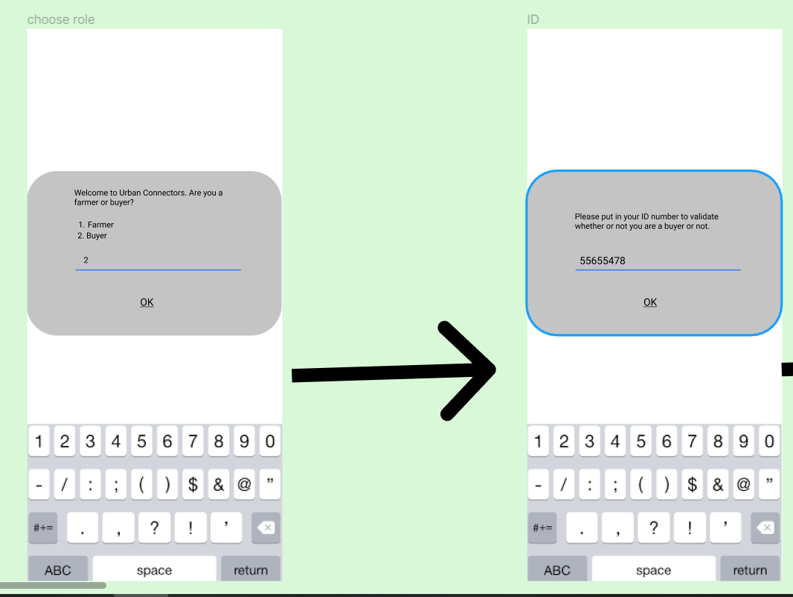

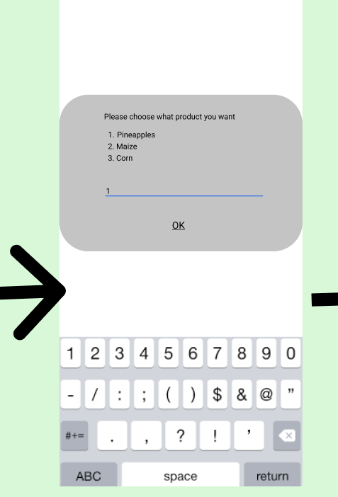

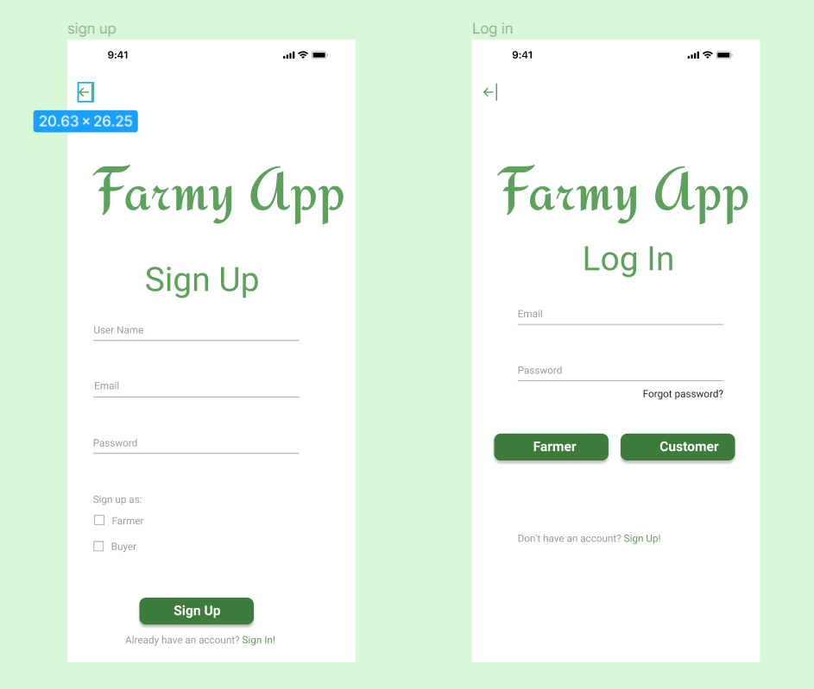

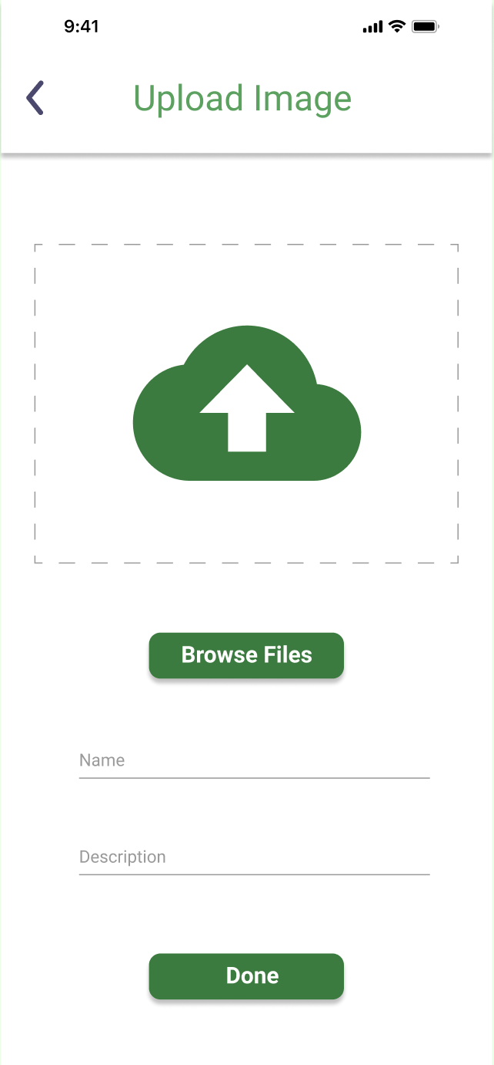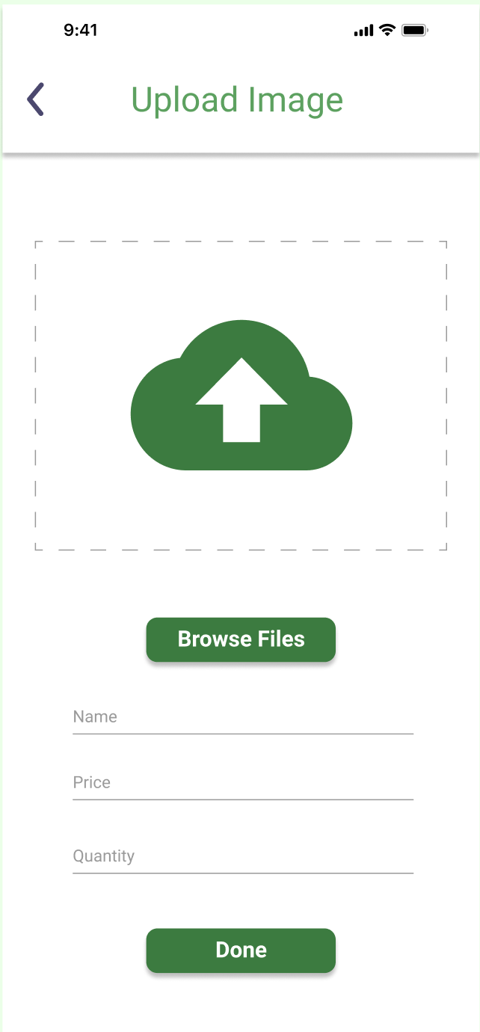

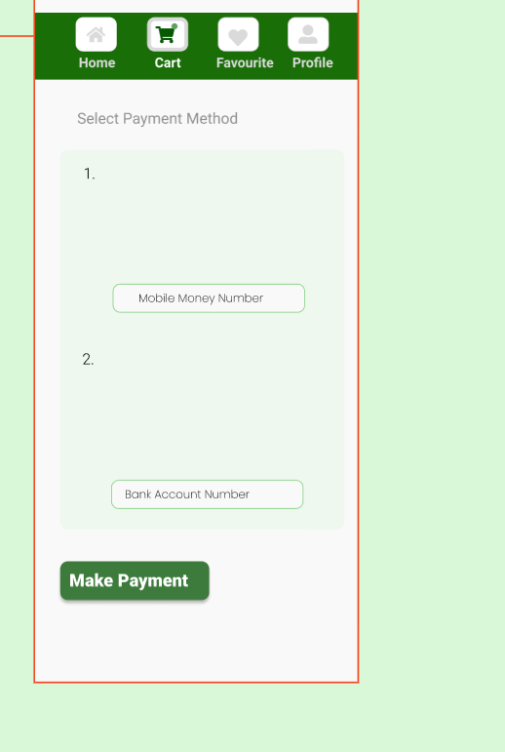

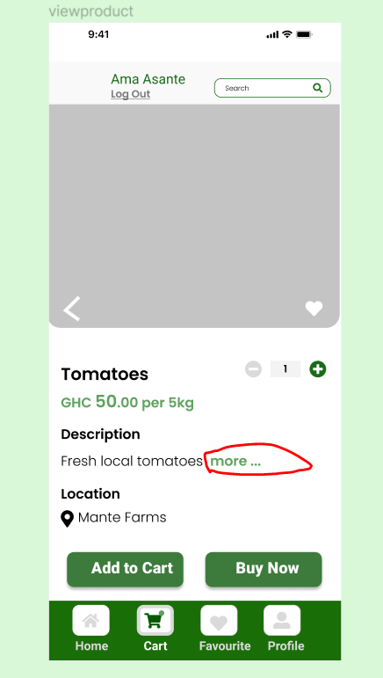

USSD

USER 3

Tested USSD app

Observations

1. Implement a back feature on the app
2. Choose a place and time when the products ordered should be delivered and when it will be received.
3. Increase the text size
4. Develop a USSD for buyers to avoid assuming that everyone has a mobile phone (Joseph this is simple, lol)
5. Show the feature of a text message that tracks whether the product has been delivered.
6. Need a field where the buyer inputs their phone number
7. Terms and conditions should be on the first page for them to avoid cancelling orders unnecessarily
8. More categories for the fruit pages e.g Fruit, Vegetables

User experience and validation of the existing user metrics

This user rated the app to be 7/10 and experience and feel of the app to be 10/10. He described as being very solid, simple, and holistic.

**Usability testing feedback – Wisdom & Afsanat**

**User 1**

* The user took time to read the guide

The app was not interactive enough, so she experienced errors with the typing; The user found it difficult to locate the “add to cart” functionality; The checkout process was also not clear to the user

She suggested that we change the “proceed” button to “checkout” button to enable her to discern the checkout easily as the proceed button was vague (she did not know it was “proceed to check out.” She thought it was like proceed to the next page); She did not scroll down. Apparently, she did not know that the page could be scrolled. We could add a scrolling bar to the right to indicate that pages are scrollable; She said she would not use and app to order farm produce. She prefers going there herself.

She was happy to see the success message at the end of the transaction

The signup button was not visible. She did not know that it was there, and we had to tell her ourselves

**User 2**

* Some text in the buttons is not well aligned (I think this was the login page)
* During signup, there is a space for username, email, and password. She suggested that the username field should be changed to full name as the email can suffice for username
* She suggested we could add phone numbers so we can easily reach out to people
* **Critical Feedback:** She said we should categorize the farm produce, so users find what they want under specific sections and not putting everything together. Example, we could have a section for fruits, vegetables, dairy products etc so we narrow down the user's searching overhead
* She pointed out that we could add quantity to the increase and decrease buttons on the checkout page
* “Location” should be changed to “product location” (on the checkout page)
* There is a typo on the add to cart page. There is a button that says, “continue ordering” instead of “continue ordering.” She suggested that we could even make the button more descriptive by changing the name to something like “add another product”
* We noticed some consistency issues when the user was interacting with the prototype. The button on the payment page was left-aligned. This is inconsistent with our design approach that centres all buttons. So, the button needs to be centred to maintain consistency
* After payment has been done, the page should redirect to the shopping page, not the checkout page

**MILESTONE 3**

**Usability Evaluation**

The mobile application and USSD system are the main solutions of team Chrysolite developed to solve the challenges Berekuso farmers faced with accessing buyers of their farm produce. As part of the development of the prototype, the team engaged in usability testing with the users of the system to find out users' experiences and feedback as they interact with the system. The findings from the usability testing guided the team in building different iterations of the prototype system to suit the input and observations of the user, making it efficient, usable, and simple. The usability testing process consisted of a set of metrics and usability questions used while engaging with the users. The insights and feedback gotten from the users were documented and used in prototype iterations. Below are the different usability metrics used and users' feedback under each of them:

1. **Task time:** This metric measured users' time to complete certain tasks. We calculated the average task time by adding the time all users took to complete tasks and dividing the total number of users.
   1. To log in and signup to the system, the average task time was 1 min.
   2. For customers to successfully purchase a product from the mobile application, the average task time was 2 minutes and 5seconds.
   3. For customers to successfully purchase a product from the USSD system, the average task time was 1 min and 37 seconds.
   4. For buyers to successfully upload their products, the average task time was 23 seconds.

Overall, from a google form we made users fill, out of the 10 users interviewed, 8 of them found that the system did not take them a lot of time to figure out how to complete the tasks. Some of the specific feedback we got regarding the time it takes the users to complete tasks is that the process is not confusing, and thus they could easily complete most of the tasks faster. Some buyers mentioned that for some tasks such as increasing the number of products they wish to buy, there is no description but an increase and decrease icons which took some users a long time to accomplish that task since they did not understand what to do.

1. **Number of errors**: This metric measures the number of actions users did wrongly when accomplishing certain tasks. We calculated the average error rate to measure the number of errors; Average Error rate = Total number of errors/ Total number of attempts. Below are the main errors observed and their error rate:   
   1. To log in and signup to the system, the greatest number of errors users were performing included attempting to write their credentials in spaces that do not accept texts and trying to log in before signing up. The average error rate for that task was: 6 ÷ 11 = 0.54, which demonstrated an equal chance of the user performing such errors.
   2. For customers to successfully purchase a product from the mobile application, frequent errors mainly included clicking unclickable buttons. Thus, the average error rate was: 10 ÷ 23 = 0.43, which indicated a slightly lower probability of committing that error.

Overall, 4 of the 10 users interviewed believed that there was too much inconsistency in the product, leading them to make some of the mistakes. For instance, a user mentioned that most of the buttons were aligned to the center, but for one page, the submit button was aligned to the right, which led her to ignore it since she was not expecting it to be placed at that place.

1. **Success score:** This measured the number of tasks successfully accomplished by the users and the simplicity and understandability in completing them. To measure it, we calculated the success score, which takes the total number of completed tasks divided by the total number of attempts.

Success score = Total number of completed tasks/ total number of attempts

Most of the tasks on the mobile application and the USSD system were successfully accomplished but with several attempts. For the mobile application, the average success score was 7 ÷ 20 = 0.35, while the success score for the USSD system was 2 ÷ 3 = 0.66, which was more than the average, indicating a higher chance of users successfully completing all tasks.

Overall, only 1 out of 10 users interviewed believed that the system is unnecessarily complex. Also, 1 user mentioned that they would need the support of a technical person to complete all tasks successfully. Contrary to these experiences, all 10 users interviewed affirmed that most people would learn to use this product very quickly, mostly because before starting to use the system, there is a learning guide to direct them on what the system does and how to accomplish key tasks. Based on the users' feedback and metrics, the mobile application and USSD would be successful.

After asking users specific feedback on the different tasks, the team asked for general feedback on the system and how well certain features could be represented to improve user experience. Below are some of the general feedbacks collected from the users:

USER 1

He felt that the application's state was good and that the USSD rightly deals with the issue of lacking data. However, the user mentioned a certain concern being the catering of errors from the drones' flight and the monitoring needed as would it have to be automatic or constantly watched. Finally, he mentioned the issue of handling errors and issues such as birds and mid-air collisions. Mechanical aspects that we had not considered earlier. His feedback helped us deal with the metric of the number of errors.

USER 2

She mentioned adding the ability to rate farmers and their products to deal with the aspect of scammers and increase the security and reliability of the application. This was tailored to the mobile application.

USER 3

She said that the application was relatively easy to use. She had no difficulty signing up and logging onto the mobile app as a buyer. He also mentioned that adding to the cart was very straightforward and quick. However, she did say she wished there was a feature that allowed you to rate the farmers and the app in general.

USER 4

User 4 found the application aesthetically pleasing. In terms of usability, he rated it a 4 out of 5. He highlighted that we could improve the user experience by separating the items on the checkout page into individual pages because it had too much content for just one page.

USER 5

She gave us the following feedback: On the stocks page, allow farmers to indicate pricing; Allow users to indicate the quantity of produce when uploading their stocks; sign up for farmers need to take their address.

USER 6

User6 focused on the USSD system and gave us the following feedback: Allow the user to input the numbers; Increase the text size; Need a field where the buyer inputs their phone number; Terms and conditions should be on the first page for them to avoid canceling orders unnecessarily. The user rated the application 10/10; however, he gave a 6/10 to the USSD system and believed it could also be 10/10 if we implemented his feedback.

USER 7

She suggested that we change the "proceed" button to "checkout" button to enable her to discern the checkout easily as the proceed button was vague (she did not know it was "proceed to check out." She thought it was like proceed to the next page); She did not scroll down. She did not know that the page could be scrolled. We could add a scrolling bar to the right to indicate that pages are scrollable; She said she would not use an application to order farm produce. She prefers going there herself; Increase the signup button color strength because it is not visible.

USER 8

She suggested that we allow users to add phone numbers while signing up so we can easily reach out to them for delivery purposes and errors in their order. Also, she suggested that the username field on the signup page should be changed to full name as the email can suffice for username. Lastly, she said we should categorize the farm produce so users can find what they want under specific sections without putting everything together. For example, we could have a section for fruits, vegetables, and dairy products to narrow down users' search overhead. Her feedback helped us improve the metric of task time and success score.

**Prototype/Semi-functioning prototypes acted out**

After improving the system based on the feedback and usability testing conducted, the team demonstrated the prototype of our system by filming the process. Below are links to different videos of both users and designers acting the prototype out.

1. The following video is a demonstration of the mobile application prototype with all the changes made based on the feedback gotten from usability testing: <https://drive.google.com/file/d/1CZCJQfRYbgnU6tZ5VrLpEIJG6EoYLyxt/view?usp=sharing>
2. The following is a video of a user interacting and sharing their experience with the USSD semi-functioning prototype: <https://aucampus-my.sharepoint.com/:v:/g/personal/hephzibah_emereole_ashesi_edu_gh/EUinwos8v0RMi0DNJifwoJkBZlb-o2ax78JFNhLpIhqFsw?e=4tJXOR>
3. The following is a link to the video of a walkthrough of the USSD prototype with all the feedback incorporated: <https://aucampus-my.sharepoint.com/:v:/g/personal/nana_boakye_ashesi_edu_gh/EQwt9kV78xpPmLmAWFGbel4BDVgJr1uKds3nFPTD-mY68Q?e=kBhfSB>

**Appendix1: Google form responses screenshots**

1. **Questions asked**

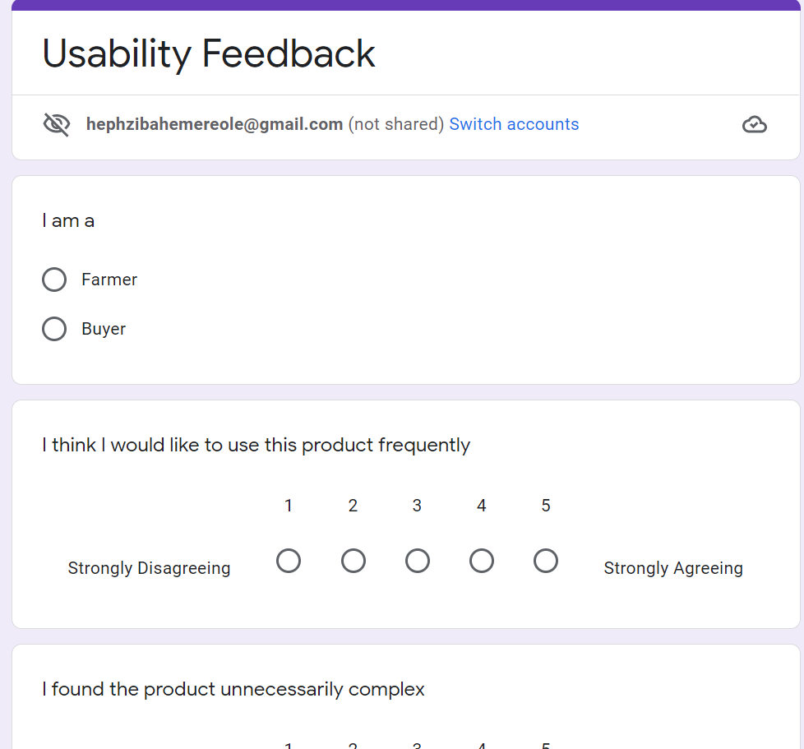

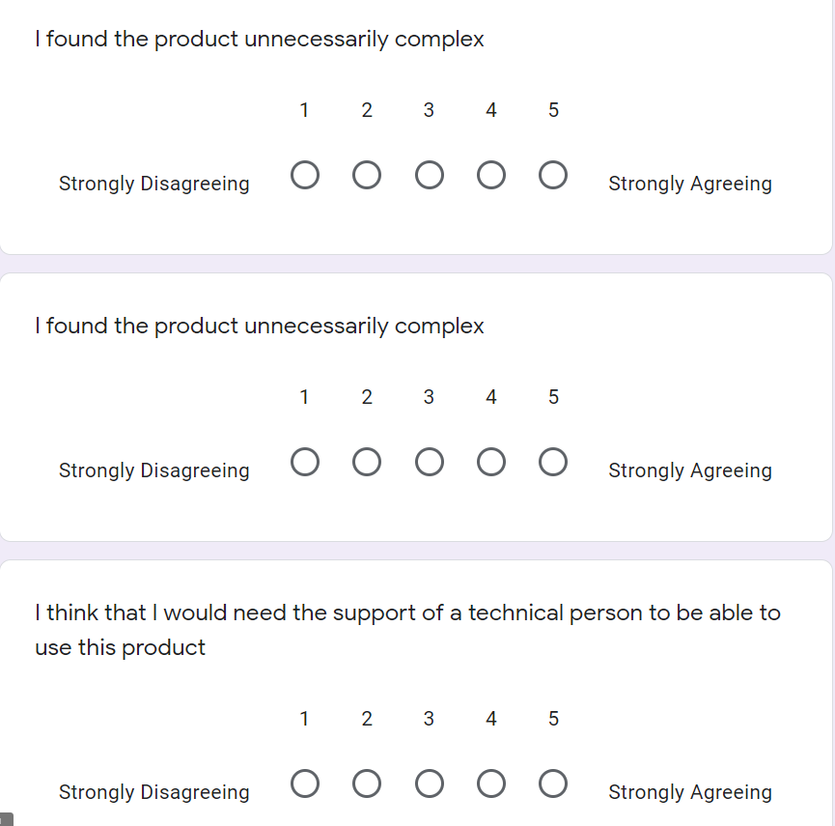

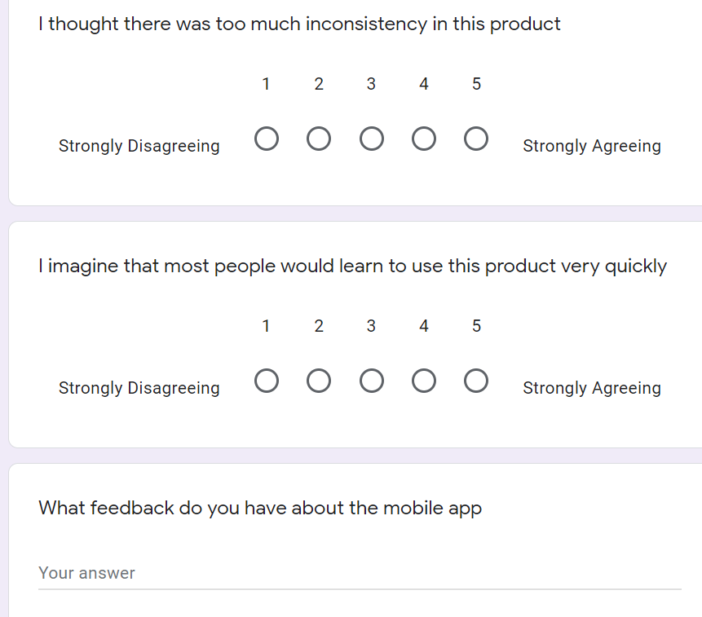

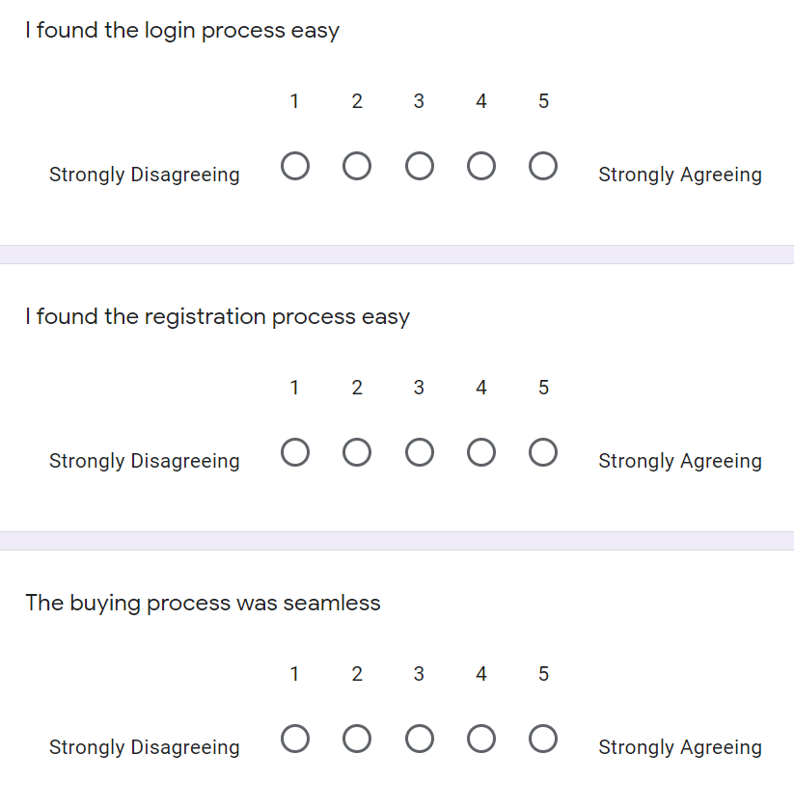

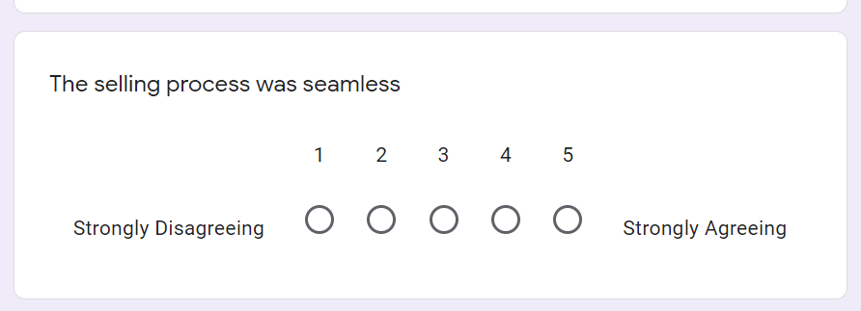

**Appendix 2- Images of usability testing**

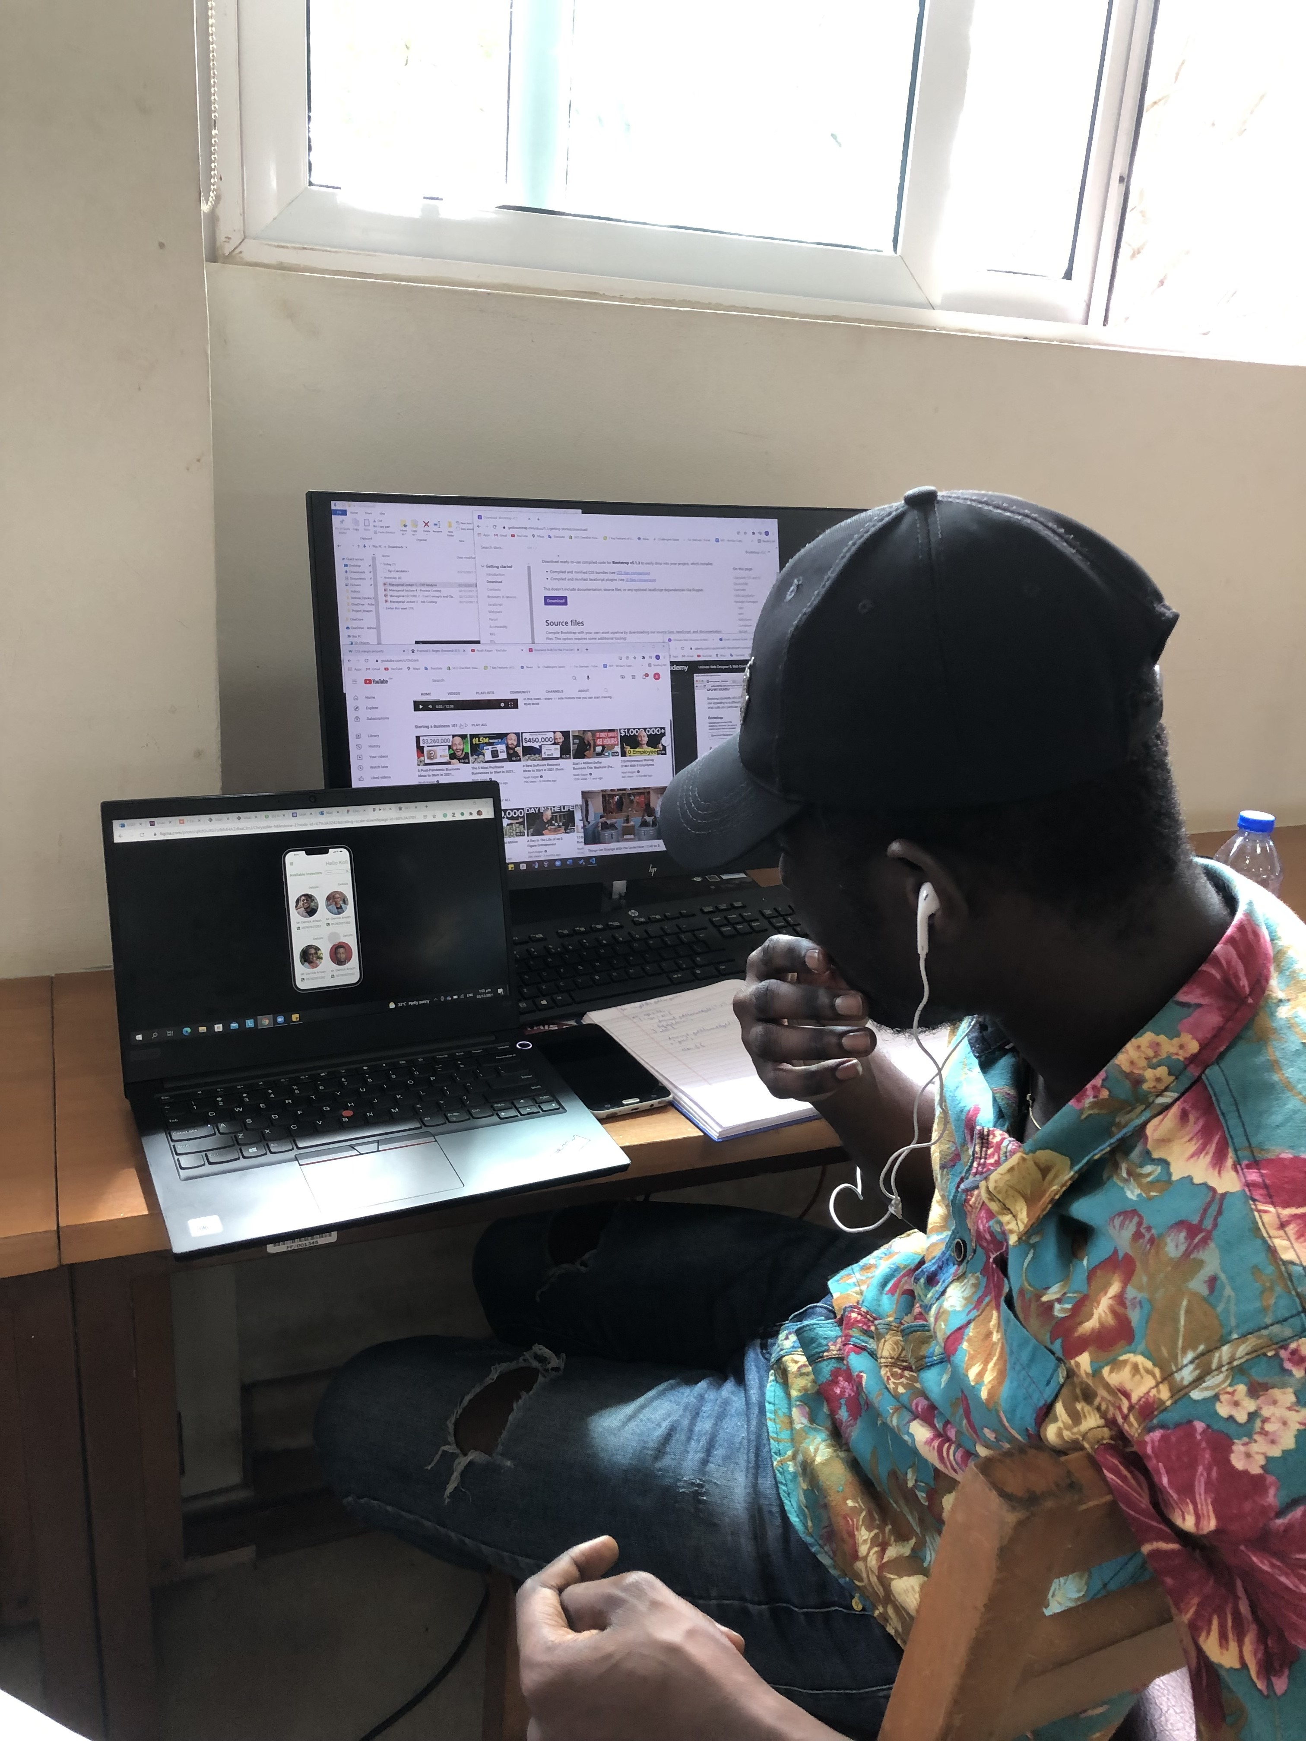

***Usability testing with mobile app***

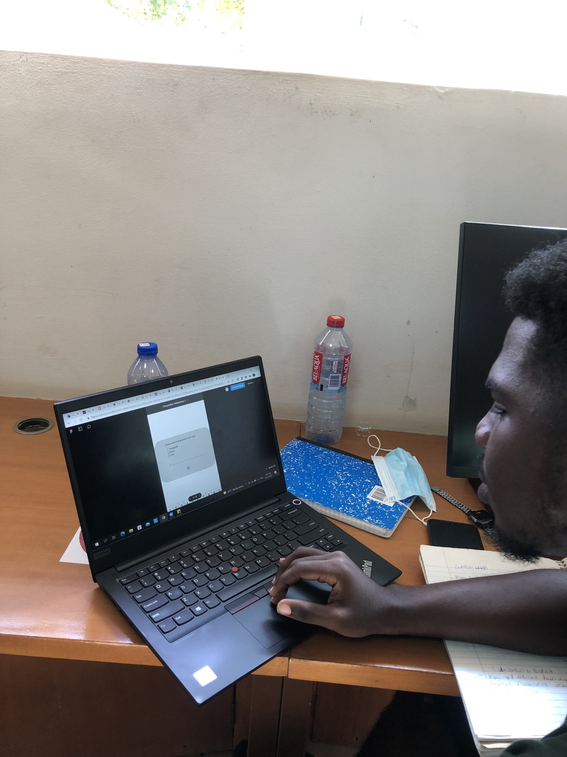

**Appendix 3:**

*The images below show snippets of the mobile app and USSD which had errors and the user gave feedback on during usability testing. From the user feedback in these images, iterations were done on final prototype as shown in one of the videos in the document above.*

USSD



Mobile app







